CAREER & COUNSELING CELL REPORT
(2015-16 session programmes )
Report of “ Awareneness Programme on Entrepreneurship cum Financial Literacy Campaign “ held under Career and Counseling Cell, 2015
Ambedkar College , Fatikroy, Tripura

The Career and Counseling Cell organized a programme on 22nd August 2015, in the Seminar Hall of the college. Both Students and teachers attended the programme. The Objective for organizing the programme is to make the students gather awareness about financial literacy. The Programme was started with the lighting of the holy lamp by President of the programme Dr. Subrata Sharma Principal-In-charge Ambedkar College Fatikroy. The technical session was chaired by Dr.Subrata Sharma Principal-In-charge Ambedkar College. Relevant lectures were delivered in the programme giving more stress on selecting suitable ways of small savings and various facilities provided by financial institutions like banks, Post Offices, NABARD etc. In the Valedictory session, students clear their queries. The programme ends with thanks to resource persons, students and staffs for their kind support to make the programme grand success and various facilities provided by financial institutions like banks, Post Offices, NABARD etc.

Programme Schedule
1.Inaugural Session (10.30 am)
11:00 AM Inauguration by lighting of the holy lamp
Inaugural speech :Mr. Lalthlamuana Darlong, AP, Ambedkar College.
Presidential address : Dr. Subrata Sharma Principal-In-charge Ambedkar College.
Vote of thanks :Mrs.Mousumi Basfore, Coordinator, Career and Counseling Cell
2.Technical Session(11 Am)
Chaired by Dr.Subrata Sharma Principal-In-charge Ambedkar College.
- Information regarding suitable ways of small savings and various facilities provided by financial institutions like banks, Post Offices, NABARD etc. by Sri Paltu Ch. Laskar, SBI-RSETI,KUMARGHAT.
- Financial literacy through playing games with the students by sri Dulal Ch. Pandit, Faculty, SBI-RSETI,KUMARGHAT.
- Lecture delivered by Sri Timir Baran Saha, DDM, NABARD, UNAKOTI, TRIPURA.

3.Valedictory Session (2Pm) by Sri Manabeswar Chakma, Asstt. SBI-RSETI,KUMARGHAT.
No of students benefitted: 54

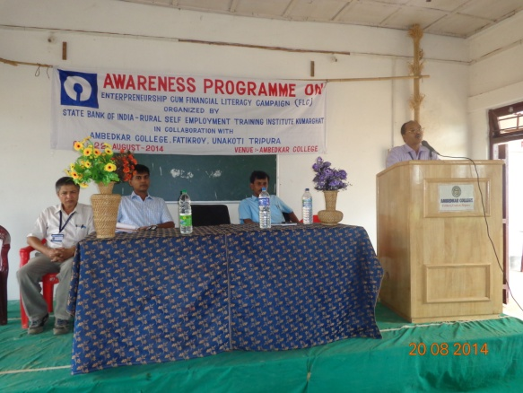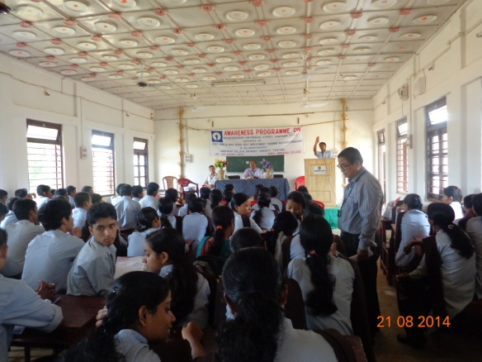
Glimpse of the programme held at Ambedkar College, Fatikroy.

Report of “ Awareneness Programme on Know your Armed Forces & Know your Arms(Weapons)” held under Career and Counseling Cell, 2015
Ambedkar College , Fatikroy, Tripura

The Career and Counseling Cell organized a programme in collaboration with The Rising Sun Battalion, Assam Rifles on 5th August 2015 in the Seminar Hall of the college. Both Students and teachers attended the programme. The Objective for organizing the programme is to make the students aware about the Army or Armed forces of our country and also gather knowledge about the various ways of joining the Army. The Programme was started with the lighting of the holy lamp by President of the programme Dr. Subrata Sharma Principal-In-charge Ambedkar College Fatikroy. Relevant lectures were delivered in the programme which was followed by display of Arms/Weapons for student’s clearer idea on concept of the regimental life . In the Valedictory session, students further clear their queries. The programme ends with thanks to resource persons, students and staffs for their kind support to make the programme successful.

Programme Schedule
1.Inaugural Session (10.30 am)
11:00 AM Inauguration by lighting of the holy lamp
Inaugural speech :Mrs Padmashree Majumder, PGT, Ambedkar College.
Presidential address : Dr. Subrata Sharma Principal-In-charge Ambedkar College.
Vote of thanks :Mrs.Mousumi Basfore, Coordinator, Career and Counseling Cell
2.Technical Session(11 Am)
.
- Information regarding the life & functions of the Armed forces.
- Information regarding the various career scope in the Army.
- Video clips and lecture delivered was delivered by the resource person Col.Roshan Verma.

3.Display of Arms/Weapons (1pm)

No. of Students benefitted: 117
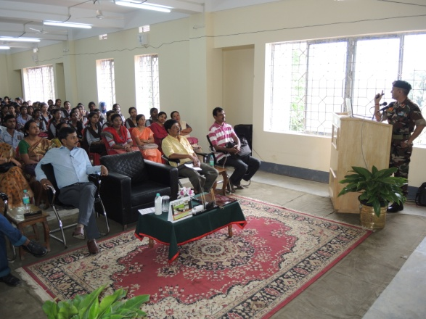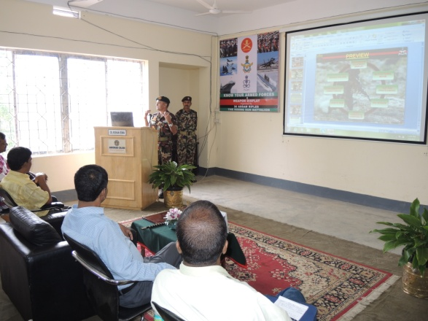

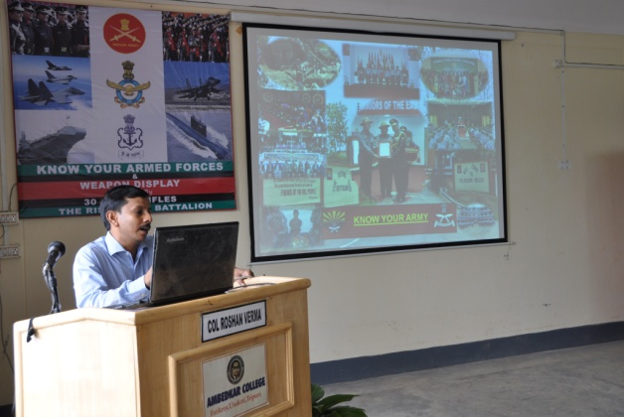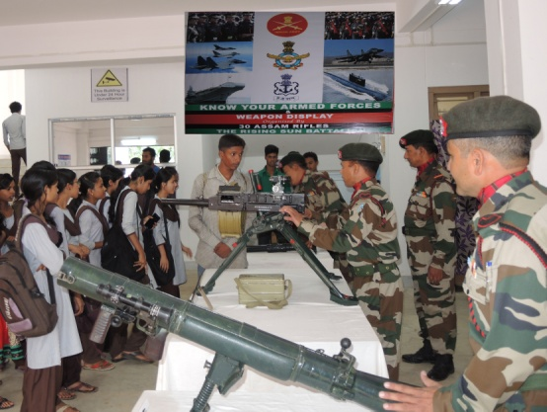

Glimpse of the programme held under Career & Counseling Cell, Ambedkar College, Fatikroy

